Project Synopsis on

Blockchain driven Internet of Things

Team Members: Shivesh Navin, Neha Bansal, Adil Ahmad

Project Guide: Mr. B.K Hemant

Department: Electronics & Communication

Abstract:

Blockchain is a distributed database existing on multiple computers at the same time. It is perpetually growing as new sets of recordings, or ‘blocks’, are added to it. Blockchain is a decentralized transaction and information management technology developed initially for Bitcoin cryptocurrency. The immense applications of blockchain also include its usage in building Internet of Things so as to fabricate more reliable IoT architectures in terms of security and communications . Our project features development of IoTain , which is a lite operating system using the blockchain concept and implementing Practical Byzantine Fault Tolerance (PBFT), Special Purpose Vehicle (SPV) and Cyber Physical Systems (CPS) technology, allowing data to be layered and stored in a decentralized manner and furnishing enhanced protection with the combined strength of the possibly millions of IoT nodes within the network.

Objectives:

1. Extend system developed during Minor Project
2. Add IoT commodities to emulate real life use cases connected via blockchain
3. Address power distribution problem faced during minor
4. Implement encrypted communication across intermediate nodes
5. Fabricate the whole system onto deployment ready PCB(s)

Tools and Technologies:

1. Tools:
2. **ESP8266**: It is a low-cost Wi-Fi microchip with full TCP/IP stack and microcontroller capability produced by Shanghai-based Chinese manufacturer Espressif Systems.
3. **ESP32:**It is a series of low-cost, low-power system on chip microcontrollers with integrated Wi-Fi and dual-mode Bluetooth.
4. **Mongoose OS:** Mongoose OS is an Internet of Things Firmware Development Framework available under Apache License
5. **Proteus & Ares :** The Proteus Design Suite is a proprietary software tool suite used primarily for electronic design automation. The software is used mainly by electronic design coupled with PCB designing toolset .
6. **Firebase :** Firebase is a complete package of products that allows to build web and mobile apps, improve the app quality and help your clients grow their business.
7. **Google IoT Core :** Google Cloud IoT is a complete set of tools to connect, process, store, and analyze data both at the edge and in the cloud.

1. Technologies:
2. **Internet of Things (IoT) :** It is an ecosystem of connected physical objects that are accessible through the internet.
3. **MJS :**  Minified JavaScript engine that implements a limited subset with no standard library and glue code.
4. **Cryptography** : Technology for securing communications between senders and receivers.
5. **C** **:** It is a general-purpose, imperative computer programming language that supports structured programming,
6. **PCB** : Printed Circuit Board (PCB) mechanically supports and electrically connects electronic components or electrical components using conductive tracks, pads
7. **MQTT** : Message Queing Telemetry Transport is an ISO standard publish-subscribe-based messaging protocol. It works on top of the TCP/IP protocol. It is designed for connections with remote locations where a "small code footprint" is required

Methodology:

1. **Commencement:** The project begins addressing problems faced during minor project and enhancements/additions to existing configuration .
2. **Testing:** The divided components would be tested individually.
3. **Implementation:** This phase would require the assembling of various components followed by final testing of the entire project and fabrication .

Challenges:

1. Addressing Power Distribution issue
2. Securing communication via end-to-end private key encryption specific to each node so as to eliminate possible eavesdropping
3. Fabricating Plug and Play ready stand-alone modules

When the no of nodes increased in the prototype , we encountered unexpected restarts and suspensions of nodes which were not easily traceable . This was due to dip in net current supplied per node from the common external power supply . It is required to implement separate PSUs exclusive to each unit so as to prevent node icing due to power failure . Securing communication is also a challenge since the communications occurs through adjacent node to node rather than an end to end approach. It is vital to implement a end to end encryption so as to prevent cases of eavesdropping , in case a unit gets compromised . All the units also need be facribated onto a deployment ready PCB which will help realizing a real plug and play architecture signifying effortless extension of blockchain networks . This will include inbuilt distribution of resources on each of the units .

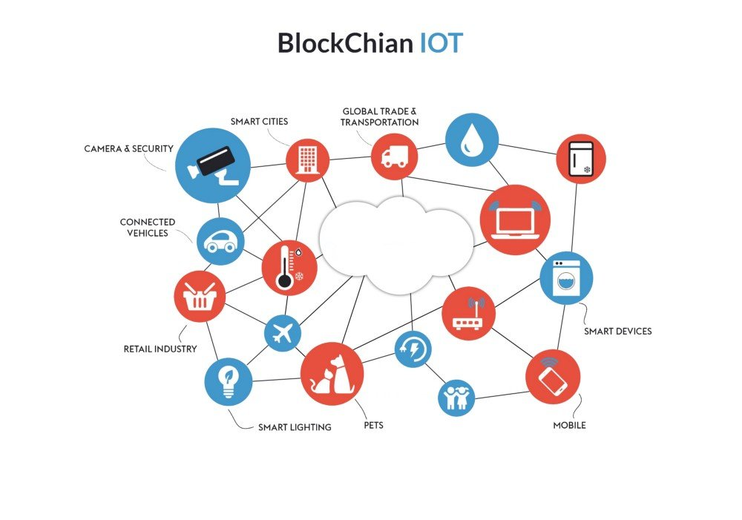

Source: IBM

Future Scope and Applications:

Blockchain technology can surely contribute to the emergence of intelligent infrastructure in the field of Internet of Things. Although the extension of this concept has inevitable shortcomings such as security, scalability, data analysis, etc. which further provides scope for research in various sectors of industrial automation, resource management, etc. This would help the Internet of Things realize its true potential.